Luche Louw
Customer Insight & Churn Prediction – Lewis Group South Africa
Africa
Applied Data Analysis & Predictive Modelling with Python- Section D
Data Science Practitioner Sprinter
Section D – Communication & Recommendations (5 Marks)
Summarise the SQL integration, data findings, and ML performance.
SQL integration:
In this project SQL was integrated into Python by using the sqlite3 library. Database and its tables were created. And, a connection was established enabling me to connect directly to the data in order to extract insights from it.
Data Findings:
Once the connection was established, I imported libraries such as Pandas, Seaborn, and Matplotlib. These libraries were used to manipulate data and to visualize that data. I was able to find insight such as:
- Average loyalty score by region
- Complaint rate by category
- Satisfaction distribution by account type
- Bar chart: average spend per region
- Heatmap: correlation among Loyalty Score, Satisfaction Score, and Total Spent
- Boxplot: Total Spent By Account Type
ML performance:
In this project, I built two models, one using Random Forest Classifier and the other using is Logistic Regression Classifier. I evaluated the performance of these models by displaying their confusion matrix, as shown below:
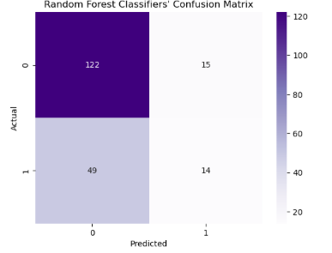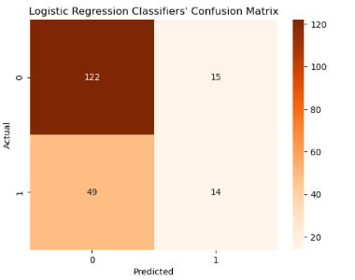

As seen in the results, both models perform well in predicting the outputs, with their performance metrics mirroring each other. However, in terms of accuracy, the Logistic Regression Classifier achieved 68.00%, while the Random Forest Classifier achieved 95.50%.
Interpret key insights
The average spent per transaction
The average spent per transaction is of the top 10 customer ranges from R16 230.00 to R19 990.00. However, 60% of these customers churned.
The average spent by region is:
Western Cape - R9 749.83
Eastern Cape - R10 274. 11
Limpopo - R10 327.91
KwaZulu- Natal - R10 882.43
Gauteng - R11 119.51

Churn count

Out of the 800 transactions that were recorded, the following shows the number of instances where customers made purchases from the Lewis store within a 90-day time span:
Gauteng - 87
KwaZulu-Natal - 58
Eastern Cape - 44
Western Cape - 41
Limpopo – 21

Gauteng shows the highest customer activity within a 90-day period, while Limpopo shows the lowest, indicating potential opportunities to increase engagement in less active regions.

Customer reviews:

It reflects on how the customers feel about items in different categories. Complaint helps to feature out what areas need to be worked on and highlights reasons why customer churn.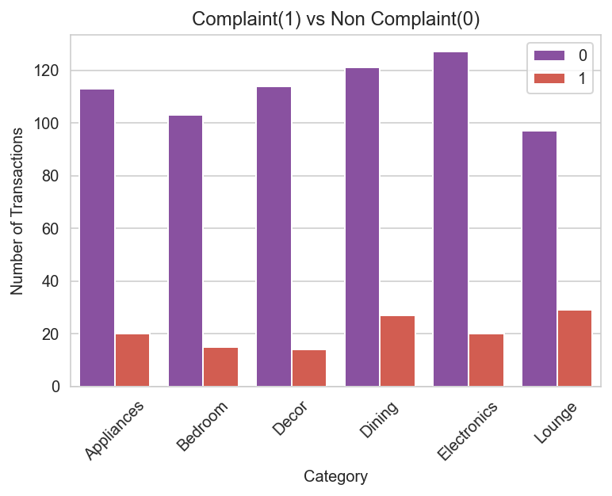

Feature importance:

This measures the categories that play an important role in the Ransom Forest Classifier model. Spikes in spending influences whether people stay or leave. The length of time customers stay loyal to the Lewis store matters, longer-tenured customers are less likely to churn. Satisfaction is moderately important, showing that happy customers are less likely to leave. Customers in Gauteng slightly affect churn, but less than the other factors.

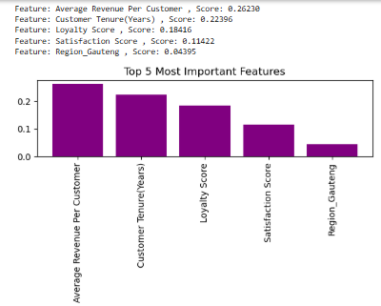

Provide 2–3 practical business recommendations for Lewis Group to reduce churn.
Based on the insight that I was able to share. The recommendations that I do have is to:
- Improve customer satisfaction – Satisfied customers are less likely to leave. The Lewis Store can collect feedback, reviews and surveys and respond quickly to complaints. Focus on areas with the most dissatisfaction in order to improve those areas.
- Focus on high spending customers – The average spent per customer is the top predictor of churn. High value customers contribute most to revenue. Identify customers who spend a lot but may be at the risk of leaving and offer them personalized offers, discounts and premium service to keep them engaged.
- Engaged with long-term customers – Tenure matters, recognize and reward long-term customers with special recognition to make them feel valued and reinforce their loyalty. As loyalty score is an important feature, enhance programs that reward and give exclusive offers to loyal customers. Learn their buying behaviours, encourage repeat purchases and communication through social media, website notifications or events.

